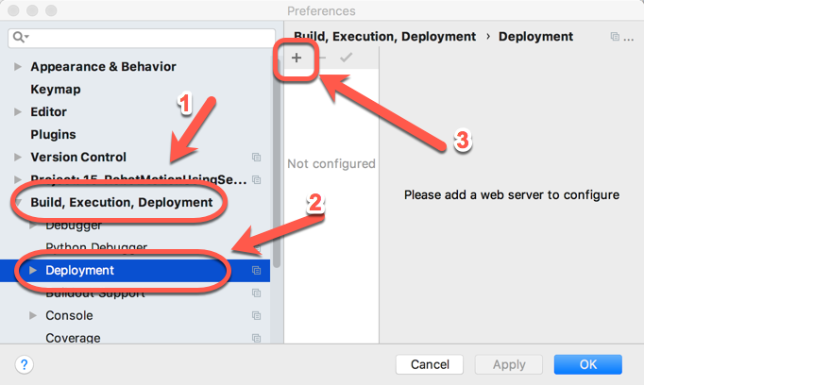**To setup a project for robot work:**

**File ~ Settings, then**

**And then:**

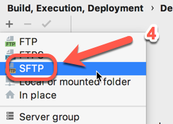

**And then**

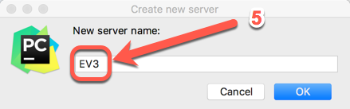

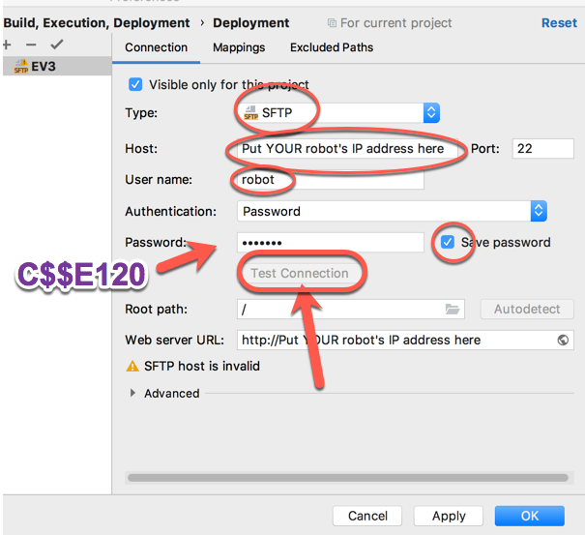

**Then:**

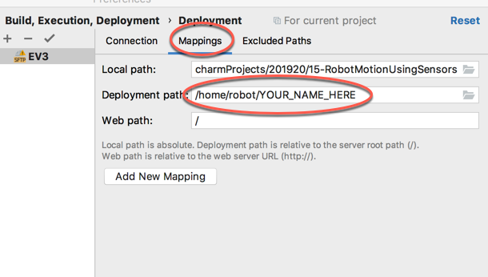**And YES when it asks about authentication.**

**Finally:**